Supplementary Figures
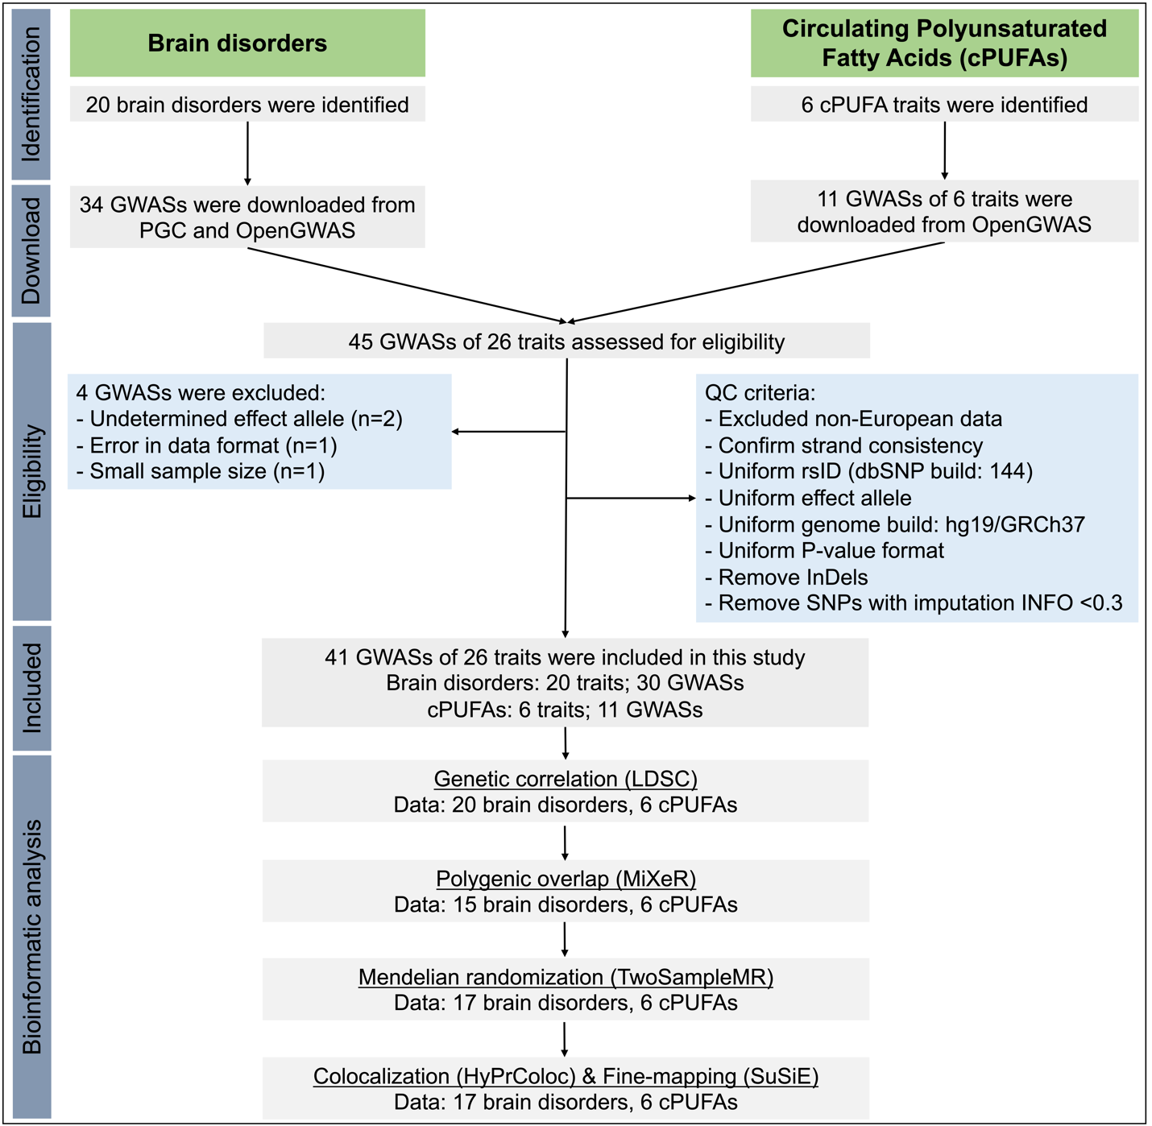
Figure S1. Overview of the study.
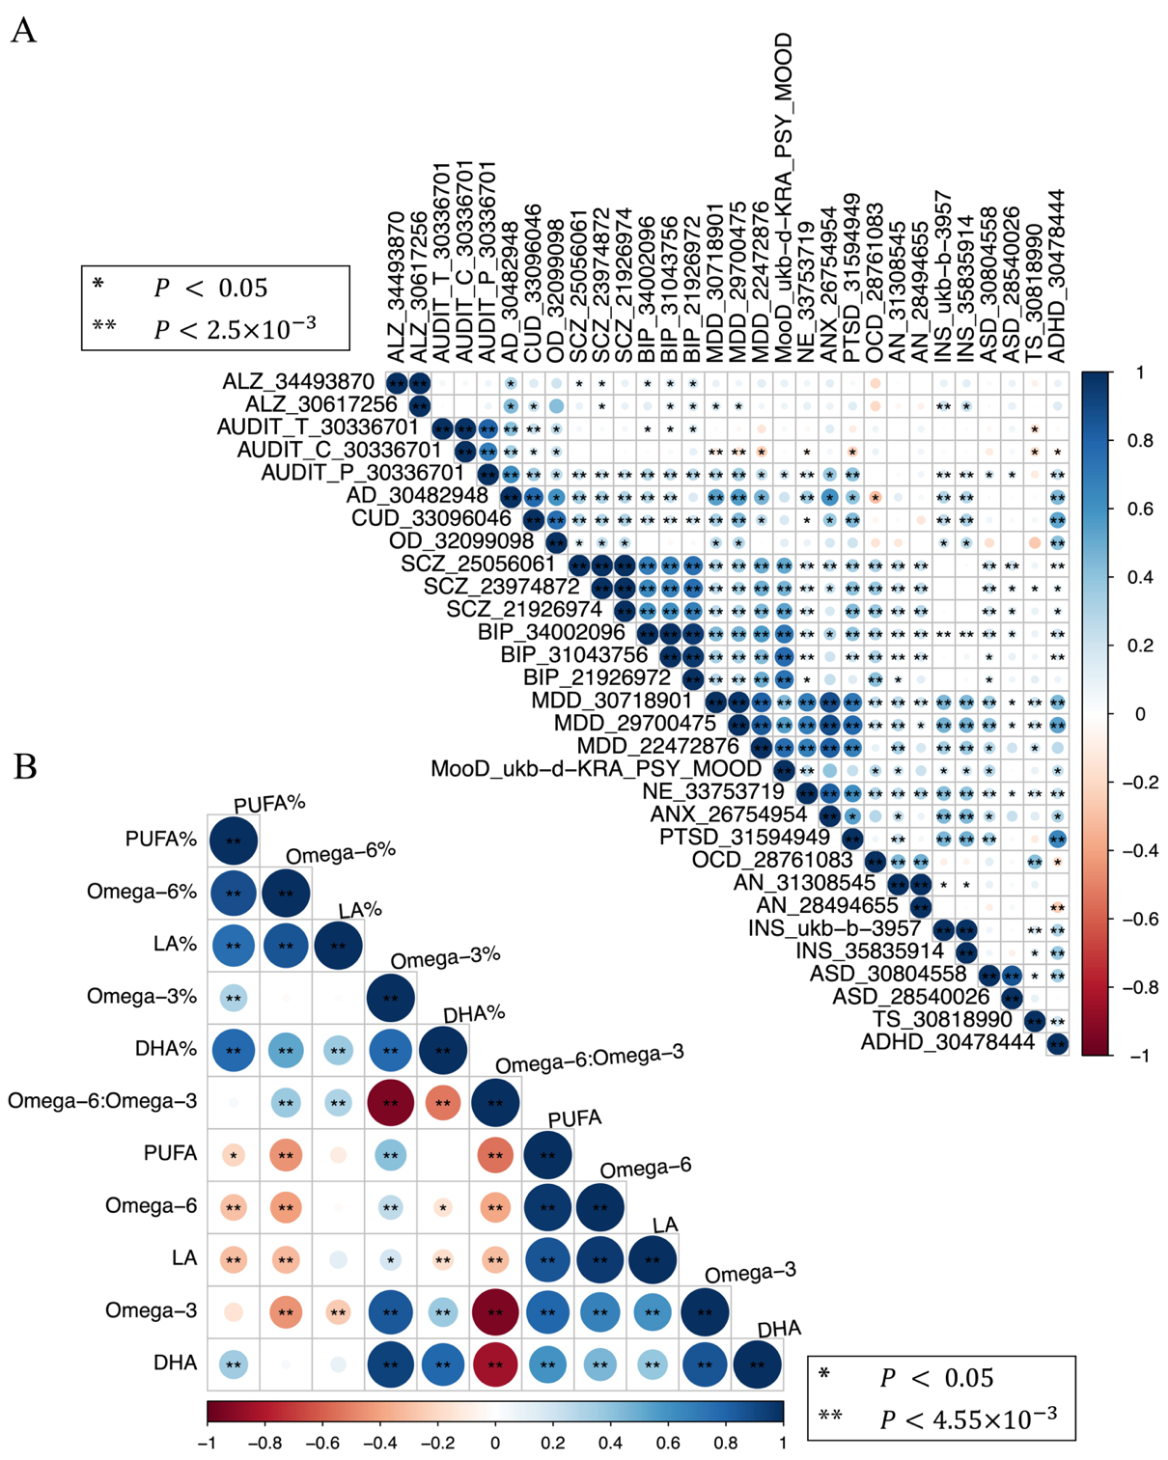
Figure S2. Pairwise genetic correlations A) between brain disorders and B) between cPUFA phenotypes. GWAS summary statistics of brain disorders are presented in a format with the phenotype_PMID. P-value cutoffs of 0.05, 0.05/# of tests are used to represent different levels of statistical significance; colors are used to represent the degree of genetic correlation (r_{g}) between two traits.
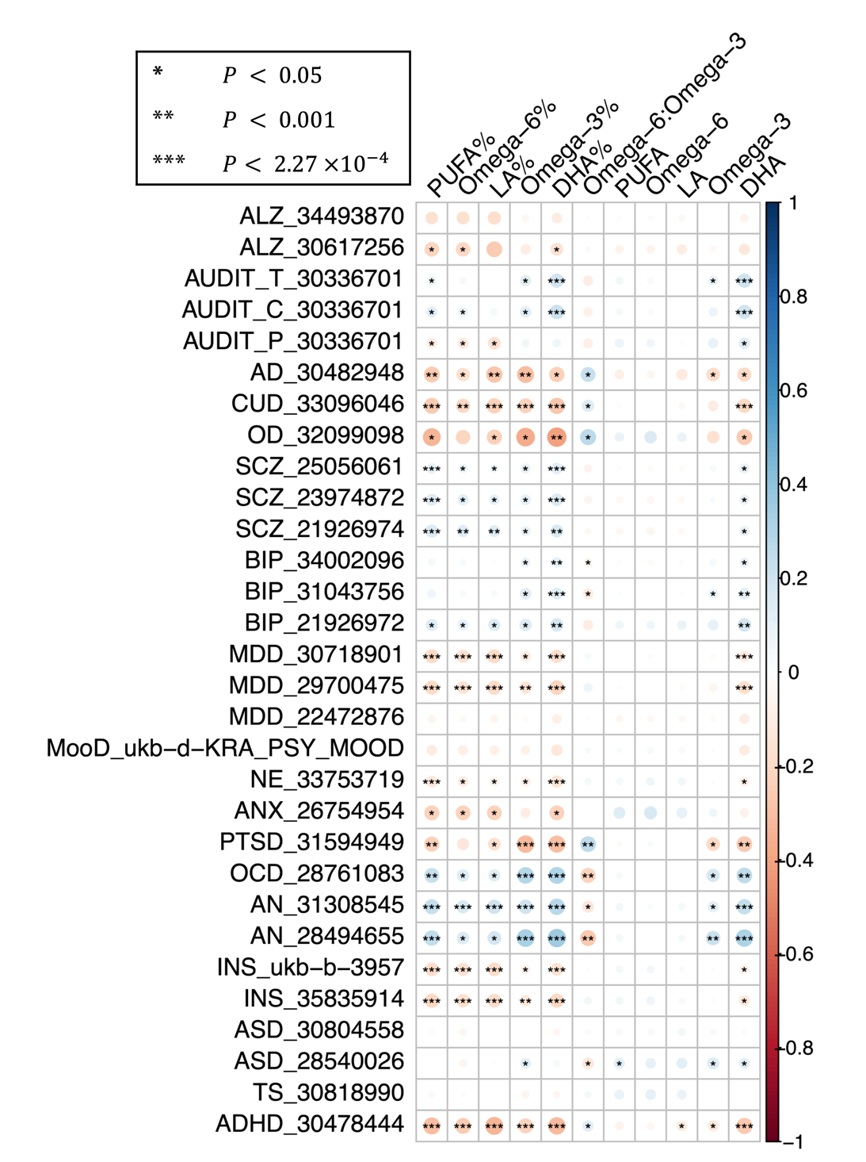
Figure S3. Pairwise genetic correlations between cPUFAs and brain disorders. P-value cutoffs of 0.05, 0.001, and 4.17×10⁻⁴ are used to represent different levels of statistical significance; colors are used to represent the degree of genetic correlation (r_{g}) between two traits.
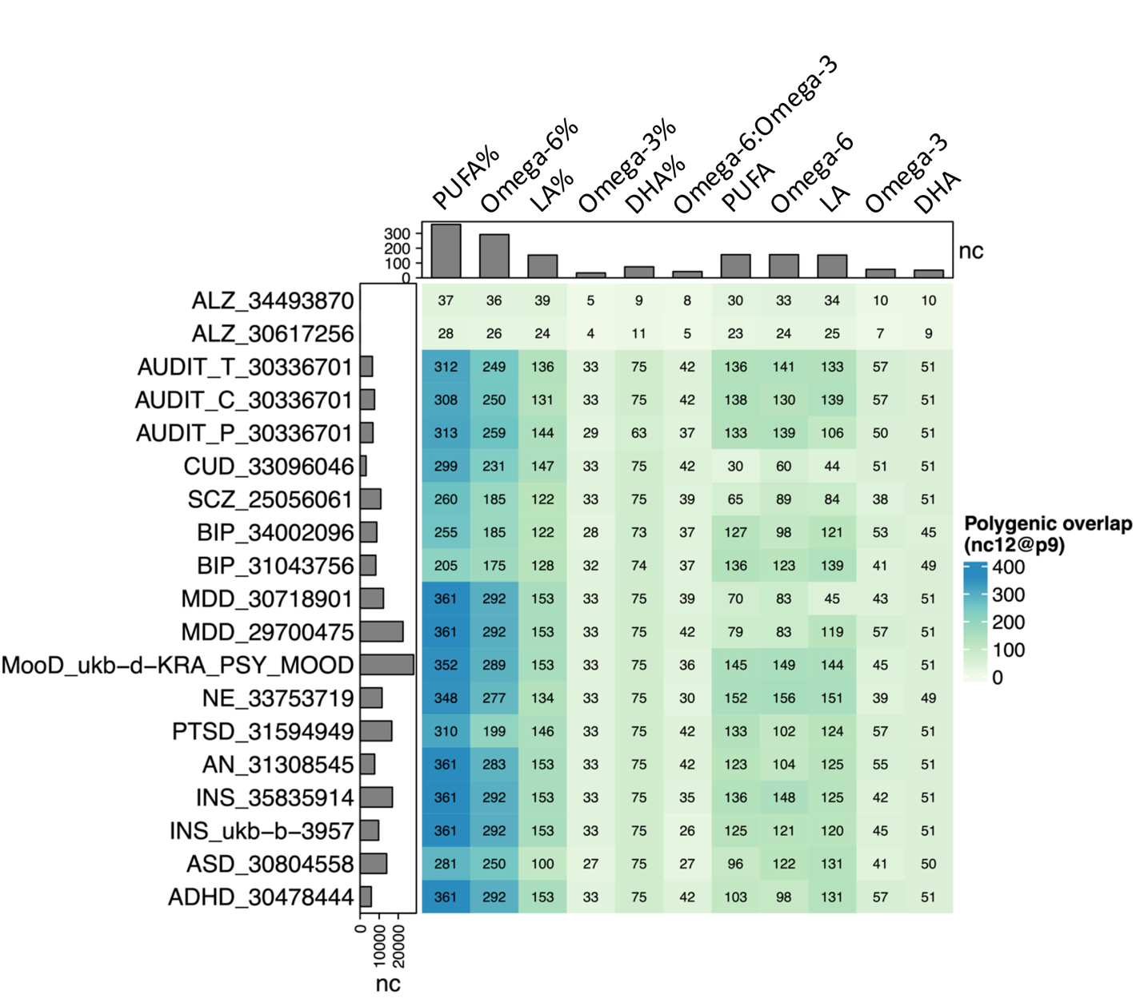
Figure S4. Pairwise polygenic overlaps between cPUFAs and brain disorders. The color and number of each box indicate the degree of polygenic overlap and the number of causally associated SNPs shared between cPUFAs and brain disorders (nc₁₂). Barplots on the top and left indicate the number of cPUFAs- and brain disorders- associated variants, respectively, which explain 90% of SNP-based heritability.
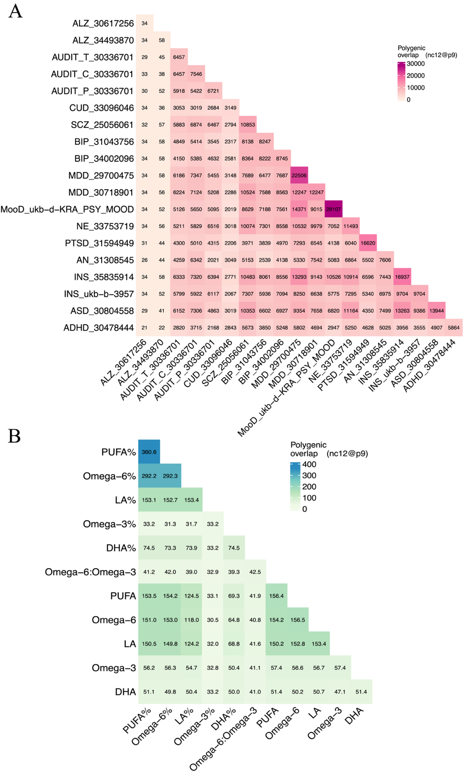
Figure S5. Pairwise polygenic overlaps A) between brain disorders and B) between cPUFAs. The color and number of each box indicate the degree of polygenic overlap and the number of causally associated SNPs that explain 90% of SNP-based heritability, shared between cPUFAs or between brain disorders (nc₁₂).
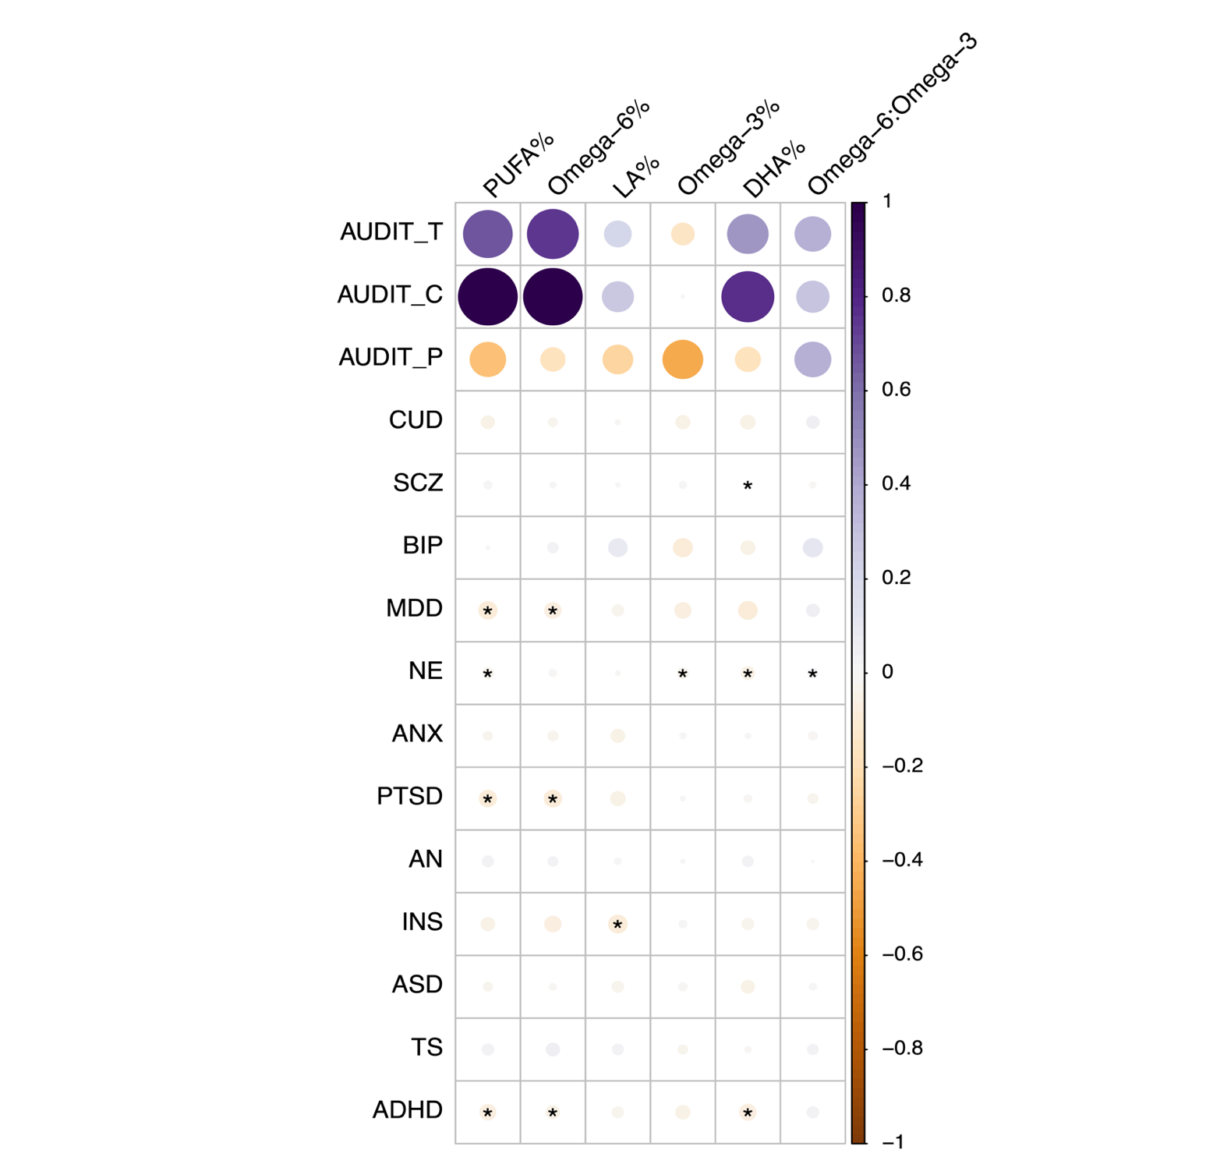
Figure S6. Reverse MR results. Heatmap summarized the causal effects of 15 brain disorders on six cPUFAs. Except for four brain disorders (ANX, ASD, PTSD, TS), an IVW P value of 0.05 is used to represent statistical significance; colors are used to represent the causal effects (β_{IVW}) of cPUFAs on brain disorders. The causal effect of four brain disorders (ANX, ASD, PTSD, TS) on cPUFAs and corresponding P values were estimated using the Wald ratio test.
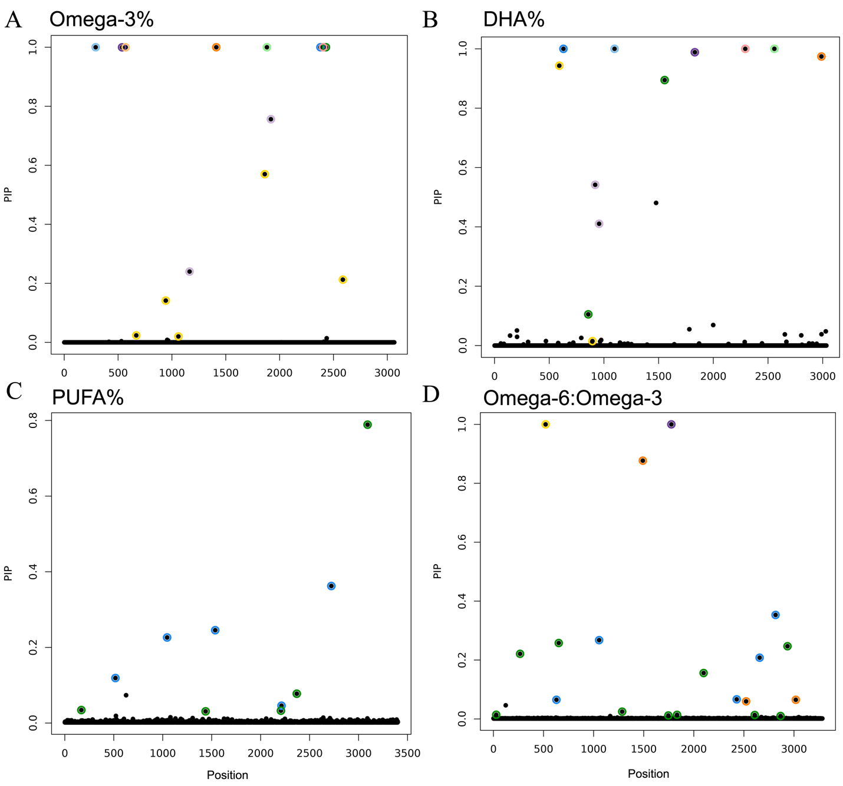
Figure S7. Statistical fine-mapping posterior inclusion probability plots in 11q12.1-11q12.3 for A) omega-3%, B) DHA%, C) PUFA% and D) omega-6:omega-3. The variant position is shown on the x-axis, with posterior inclusion probability (PIP) on the y-axis. Colors are used to represent different 95% credible sets. Each 95% credible set contains a causal variant. There are multiple putative causal variants in the region for omega-3%, DHA%, PUFA%, and omega-6:omega-3.
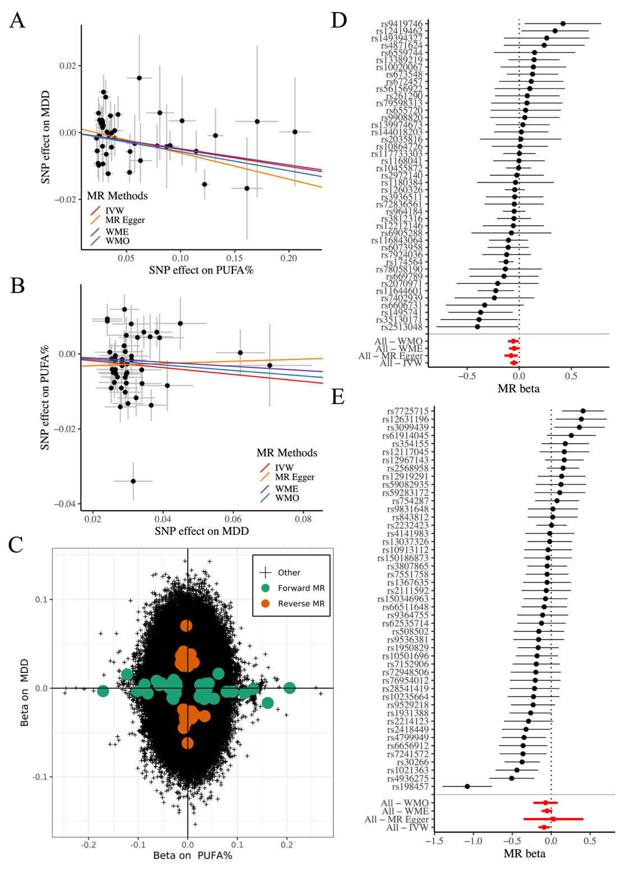
Figure S8. Bidirectional association between PUFA% and MDD. A) Forward MR estimated causal effects of PUFA% (x-axis) on MDD (y-axis). Causal effects estimated by the four models are shown by fitted lines; slopes of these lines indicate causal effect sizes. B) Reverse MR estimated causal effects of MDD (x-axis) on PUFA% (y-axis). C) Genetic effect of genome-wide SNPs on PUFA% (x-axis) and MDD. Genetic variants selected in forward and reverse MR analysis are shown in green and red, respectively. D) The forest plot shows 43 genetic instruments included in the PUFA%-MDD forward MR analysis. The causal effects estimated by the four models are marked in red. E) The forest plot shows 48 genetic instruments included in the MDD-PUFA% reverse MR analysis.
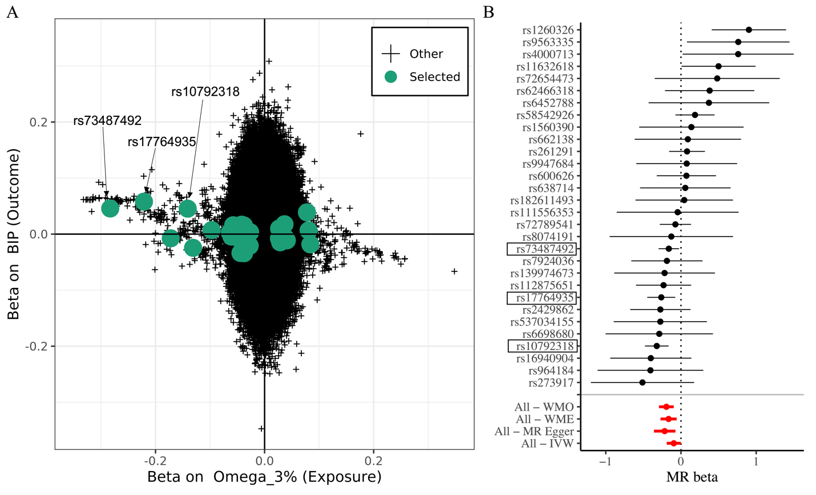
Figure S9. Differences in the SNP set in omega-3%-BIP genetic correlation and MR analysis. A) Genetic effect of genome-wide SNPs included in genetic correlation analysis on omega-3% (x-axis) and BIP (y-axis). Genetic variants that are selected in omega-3%-BIP MR analysis are shown in green. Three highlighted SNPs are in the FADS locus. B) The forest plot shows 30 genetic instruments included in the omega-3%-BIP MR analysis. The causal effects estimated by the four models are marked in red.

